Document Title Extraterrestrial Robot Explorer and Environmental Logger
Phase 2 (Planning) Project Charter
Revision 2.0
Date Issued September 19, 2016
Date Effective September 19, 2016

Department School of Engineering and Information Technology
Program Electronic Systems Engineering
Audience ESE Semester 5 Students
Author Semester 5 Development Team
Reviewers Peter Roeser, Professor
Bill Stefanuk, Professor

Revision History
Revision | Description of Change | Effective Date
1.0 | Initial Release | September 17, 2007
1.01 | Revised for 2008 | September 21, 2008
1.2 | Revised for 2009 | September 28, 2009
1.3 | Revised for 2010 | September 27, 2010
1.4 | Revised for 2011 | September 26, 2011
1.5 | Revised for 2012 | September 24, 2012
1.6 | Revised for 2013 | September 23, 2013
1.7 | Revision for 2014 | October 14, 2014
1.8 | Revision for 2015 | October 19, 2015
2.0 | Revision for 2016 | September 19, 2016

Table of Contents
Robot Explorer and Logger Phase 2 (Planning) Project 4
1. Academic Need 4
2. Project Description 4
3. Evaluation Criteria 5
4. Milestones 6
5. References 7
6. Constraints 7
7. Assumptions 7
8. Customer Requirements for New Product 8

Robot Explorer and Logger Phase 2 (Planning) Project

Academic Need
In this semester students will progress through the commercialization stages of a product, from development to integration of sub-systems to a pre-production stage.
Phase 1 consisted of recovering the information and software from Semester 4 and concluded with a demonstration of a proof-of-technology prototype.
In this second phase of the project, students will plan for the design phase to follow based on the technology of the prototype and new technologies as outlined in the phase 2 charter. In doing so, they will use processes relevant to engineering design. They will improve their planning and estimating skills, and gain an appreciation for more issues relevant to product creation.
Through the outcomes of this project planning phase, each student will be able to:
- Collect, Track, and Interpret Requirements
- Conduct and document an Information Assessment.
- Begin Preparation of Project Specifications based upon Requirements
- Create a formal Development Plan and Schedule.
- Investigate and analyze the usefulness for the project purpose of several Commercial off The Shelf (COTS) embedded Linux products. Selection criteria will be defined, a selection matrix created, and final product selection with justification.

Project Description
This phase of the project consists of three major components:
- a design review of the tethered robot with reference to the original requirements
- an assessment for a new development project based on the tethered robot technology but with a new set of requirements based upon a customer issued “Request for Proposal” and considering new technologies as outlined in the phase 2 charter
- a development planning exercise to prepare for the new development project

Planning Phase Requirements:
URL: (Requirements are identified as Must, Should, Could or Won’t.)
This phase of the project will meet the following criteria:
- Students will prepare and maintain an organized project binder including relevant project documents and reference material. [M]
- Students will prepare a Design Review of the Semester 4 proof-of-concept prototype. [M]
  - Design Review document will be prepared, and delivered. [M]
  - Deficiencies between the original specifications and the existing design will be identified. [M]
  - Deficiencies in the product quality will be identified. [M]
- Students will conduct an Information Assessment to determine readiness to begin development on a new project based on the state of the prototype as determined by the design review and the new requirements. [M]
  - Requirements will be collected and tracked[M]
  - Information Assessment documents will be prepared. [M]
  - Missing information and technical risks will be identified and communicated to faculty. [M]
- Students will prepare a Development Plan to develop a product to meet the requirements given. [M]
  - Development Plan will be prepared. [M]
  - Development Plan will address all requirements. [M]
  - Development Plan will include individual responsibilities, resource requirements and scheduling. [M]
  - Development Plan and Schedule will be controlled documents (changes logged). [M]

Evaluation Criteria
Students work will be evaluated on a weekly basis in the debriefing session with respect to the milestones. Standard rubrics will be used for this purpose. Some examples of evaluation items:
- Completeness and quality of the work
- Students’ readiness with documents, prototypes and activity log during debriefing session will be a part of the evaluation
- Up-to-date activity log book and project binder
- Active participation, timeliness and effective use of time
- Cooperation within the team and beyond

Milestones
Phase Start Date: September 19, 2016 Phase End Date: October 6, 2016
Deadline | Milestone Deliverable
September 19, 2016 | - Perform and document(written) a Design Review for the Semester 4 tethered robot prototype  - Perform an Information Assessment to determine the readiness of the development group to start the new project  - Provide all documentation and meeting minutes  - Identify new requirements (numbered list and description)  - Identify missing information and technical risks (numbered list and description)  - Prepare a Preliminary Development Plan (point form or list acceptable for preliminary plan)  - Establish Source code control procedures and system for Semester 4 Project and later Semester 5 Project
September 30, 2016 | - Establish a final Development Plan based upon the Preliminary Development Plan  - An organized project binder including relevant project documents and reference material  - Preliminary Selection matrix for embedded Linux system created and at least 50% filled out for COTS systems.  - Preliminary Specification for the Alpha Proof of Concept Extraterrestrial Robot Explorer and Environment Logger based upon Requirements elicited from the customer (Faculty).  - Topic List and Outline for Technical Report discussing implementation options for Environment Logger sensors (Technical Report to be supplied October 6, 2015)
October 6, 2016 | - Completed Selection matrix for embedded Linux system created and selection made.  - Technical Report discussing implementation options for Environment sensors.  - The deliverables of this week will occur in parallel with the start of Phase 3 –Design and Development.

- Every deadline, as indicated in the table, is the end of the week.
- The students will be evaluated with respect to the milestones and rubrics of the week. Some examples of evaluation items are listed in the Project Description section
- The marks will go to the Engineering Project 5 course
- Students are expected to conduct meetings with documentation record keeping and meeting minutes.

References
- Texts for this semester
- Instructor Handouts
- Resources that students find on the web.

Constraints
    - This project Planning phase shall be completed in 3 weeks
    - The subsequent Design Phase may begin after the first week of planning.
    - Final Integration and Test shall begin after 7 weeks.
    - Students will complete the project in groups of three or four.
    - Students will abide by the selection of (or restrictions on) any resources

Assumptions
    - Substantially working projects exist at the end of Phase 1
    - Students will use the designated project time for project work. Besides they will dedicate an average of approximately one hour every working day outside the regular class time and study/homework time
    - Students will actively participate in all scheduled activities
    - Students will make wise and efficient use of scheduled class time
• Students bench is equipped with the required instruments and required resources are timely available

Customer Requirements for New Product
The new project is based upon requirements of the Project Funding Organization (faculty). The project consists of three subsystems the first of which is a “Robot Explorer”. This robot will be required to travel over a simulated planetary Landscape (carpeted area) searching for previously deployed “Environmental Logger(s)” (subsystem number two of this project). It will receive and respond to joystick or user interface commands to start, pause and stop, and to define its search zone which will be transmitted from the “Platform Supervisor” (subsystem number three of the project). It will record the location of sites where each “Environmental Logger(s)” was found while traversing the search zone. Logging data from the Environmental Logger will be transferred to the Remote Control Robot. The logging data will be uploaded from the Remote Control Robot to the Platform Supervisor.
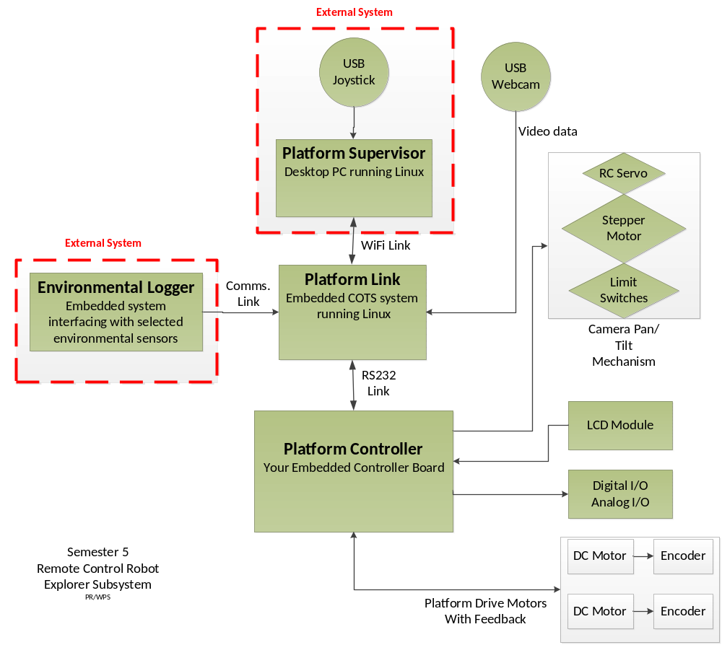
The Environmental Logger requirements and specification will be developed by the project team during this Planning Phase in consultation with representatives of the Project Funding Organization (faculty).
The project will meet the following criteria:
MUSTs
- Use the HCS12 board from project 1 as the platform controller

- Select and use one of the available supplied types of Commercial off the Shelf (COTS) embedded Linux system as the communications link to the platform supervisor (CLIP PC or equivalent).

- Select and use one of available supplied types of Commercial off the Shelf (COTS) embedded Linux system or the Axeman as the core for the Automated Environmental Logger.

- Use an RS232 serial link between the selected COTS system and platform controller.

- Use the faculty-supplied platform mechanism.

- Draw DC power from supplied batteries carried on the platform or bench supply for development and debug. The power connection shall be the only wired connection to the platform. A power budget for the complete mobile platform will be calculated or measured and appropriate portable supply specified.

- The platform controller must run a platform control program written in C and assembler that can perform the following functions as a minimum:
  - communicate with COTS system via the RS232 link
  - operate all motors and actuators on command
  - perform closed-loop speed control on the DC drive motors using the encoders for feedback
  - be able to display information on the LCD as required by the application
  - perform platform operations asynchronously of the commands received
(E.g. if the stepper motor is commanded to rotate 180 degrees, the program should be able to receive and process other commands while the stepper motor is moving.)
- There must be a defined and documented communication protocol and associated set of commands by which the platform controller receives movement commands.
- There must be a defined and documented communication protocol and associated set of commands by which the platform supervisor (CLIP PC) communicates with the platform controller through the COTS system.

- There must be an ability to monitor the status of sensors, position, and other information from the mobile platform by the platform supervisor (CLIP PC) via Wifi or other wireless network communications link.

- The finished platform must be able to perform the following actions under joystick control:
  - move from its base to a starting location under PID motor control
  - conduct a search for Environmental Loggers based upon predefined trail markers or predefined paths
  - transfer data from any Environmental Loggers encountered
  - at the completion of the search, return to base and transfer logged weather data to the platform supervisor.

- The power requirements and transfer connection for the Environmental Logger are to be determined during the Requirements gathering phase.

- Environmental Logger sensors, communications capabilities and logging options will be determined as part of a Technology Report during this Phase.

